

**Department of Computer Science & Engineering**

**CA2 GEN-AI**

**B.TECH -7th Semester (Session 2021-25)**

**Name: Anisha Jaiswal (PRN: 21070521011)**

**Q1. Generate a model in Python for representation of a bank account of type savings and balance along with transactions of deposit and withdrawals and currently create a program to generate 100 accounts with Random balance and transactions for no. of months and no. of transactions with a seed value of amount. Print all 100 accounts with the last balance and organize them by lowest to highest balance.**

**Code:**

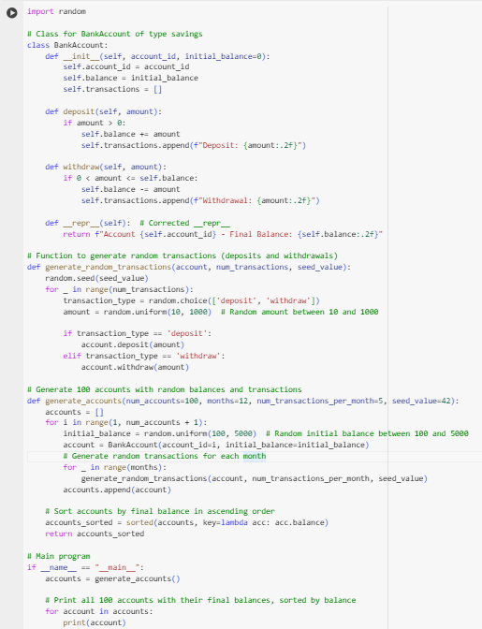

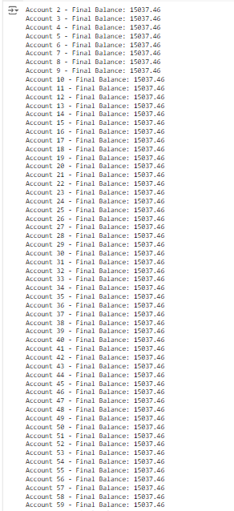

**Q6. Generate a model to represent a mathematical equation, write a program to parse the equation, and ask for input for each parameter.**

**Code:**

